Units Appendix A: Units and A/P

You may use some of the programs within the Units System to update the A/P files. Likewise, the A/P System can update the data within the Units System. However, the integration flag for sharing data between these two packages must be turned “on” within your business system.

You may add invoice entries to the A/P System through the following functions:

- Unit Purchase (UP/BIP)
- Enter Transfers and Adjustments (ETA)

This section only provides instructions for entering the invoice’s payable amount to Accounts Payable.

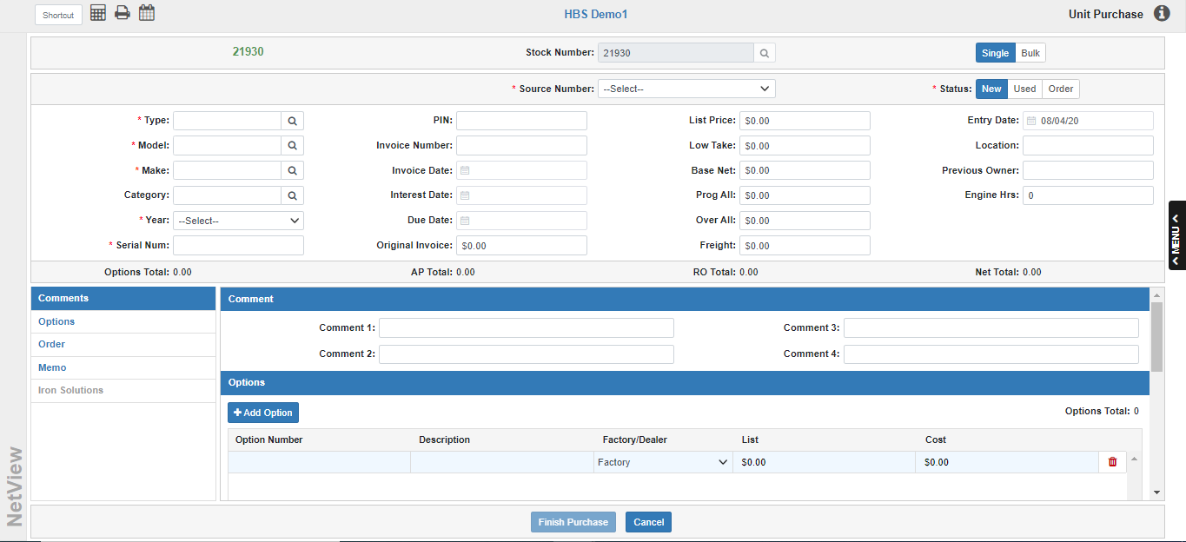

Unit Purchase (UP/BIP): You may offset part or all of your equipment purchases through Unit Purchase. Use Single mode (UP) to purchase only 1 unit or Bulk mode (BIP) to purchase multiple units at once.

For both modes, enter all of the invoice and equipment information. When you select the Finish Purchase button, you will access the financing screen.

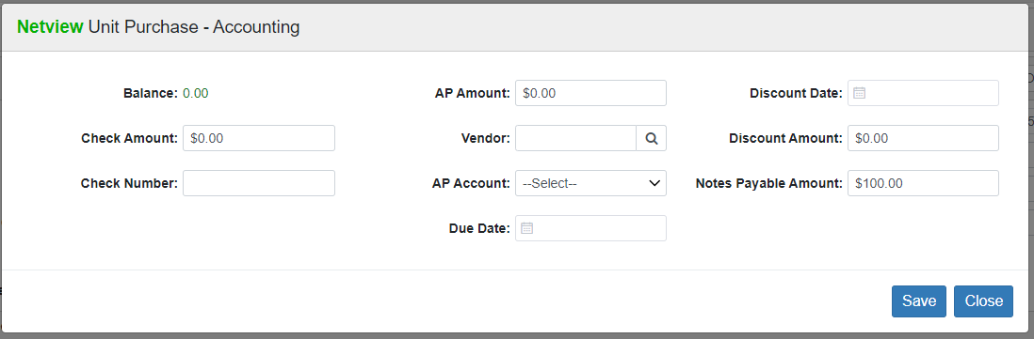

This screen displays the total equipment inventory amount (the Balance field), which you must now offset to one or several of the following accounts:

Check Amount: If you have already written a check, you enter this amount in the field. Also, enter the check number for your reference number.

Accounts Payable: If you are going to send all or a portion of the amount to A/P, enter this amount in the Accounts Payable field. Set the vendor, A/P account, Due Date, Discount Date, and Discount Amount as appropriate.

Notes Payable: If the amount should go to Notes Payable, enter this amount in the Notes Payable field.

It is possible to use a combination of all three types. Just make sure it balances to zero before you save it.

NOTE: If you are a Canadian dealer, you must use A/P to handle your tax payment on a Unit Purchase. The system will pop an error message if you attempt to do differently.

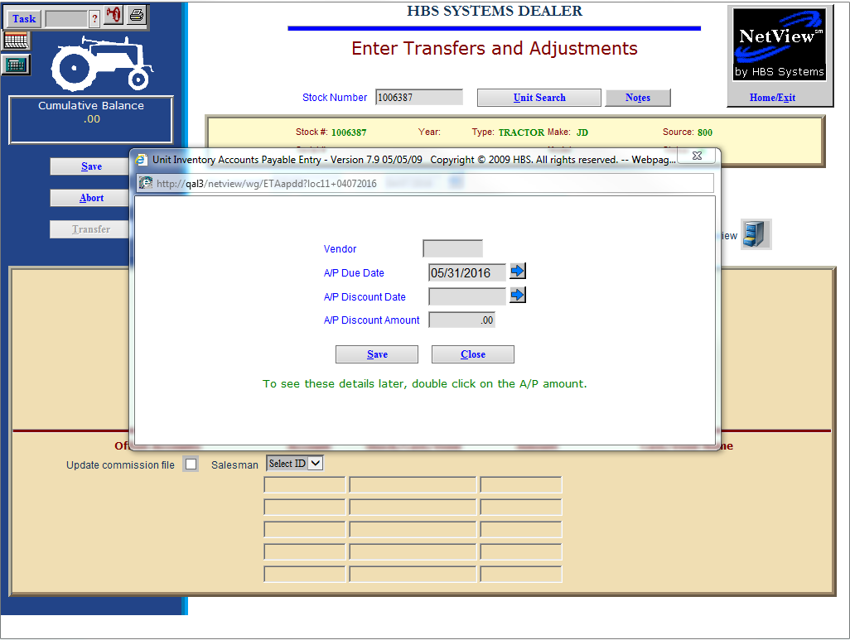

Enter Transfers and Adjustments

Entering a New Invoice: If you need to add a new invoice entry to an existing Stock Number, you may use Enter Transfers and Adjustments (ETA).

- Enter the amount on the A/P line.
- Fill in the following:
  - Vendor
  - Due date
  - Discount date
  - Discount amount
- When you post the transaction with UPJ, it will create the invoice in A/P with the entered information.
- When the A/P invoice is later paid, it will update the stock number to show that it has been paid.

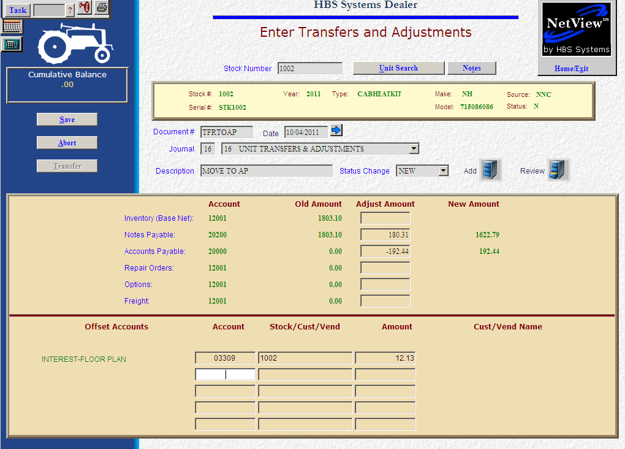

Transferring Amounts Between Notes Payable and Accounts Payable: If you want to use Print Checks in A/P to write checks for equipment notes, you can transfer all or part of the Notes Payable amount to A/P. Then use Print Checks (Alt PC) to cut the check. Here are a couple of tips:

Document # in ETA: Use something other than the invoice number to move the money from Notes to A/P. You might use APXXXXXX where XXXXXX is the date of the transfer.

Description in ETA: Describe this entry as a transfer (such as, NP TO AP 050908).

When you need to make a curtailment that includes interest, you can:

- Take the principal amount out of Notes.
- Send the principal and interest total across to A/P to pay.
- Simply use the offset accounts section to include the entry to the expense account for the floor plan interest.
- When you post this entry in UPJ, it will create one invoice in A/P for the combined principal payment and interest.
- Select the invoice and generate a check in A/P to pay it.

